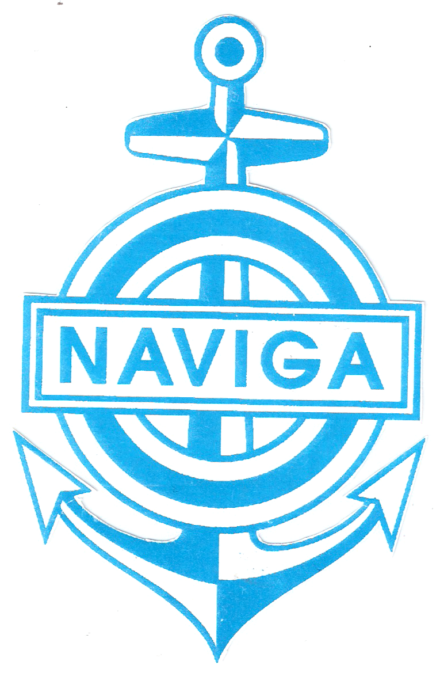World Organisation for Modelshipbulding and Modelshipspoirt NAVIGA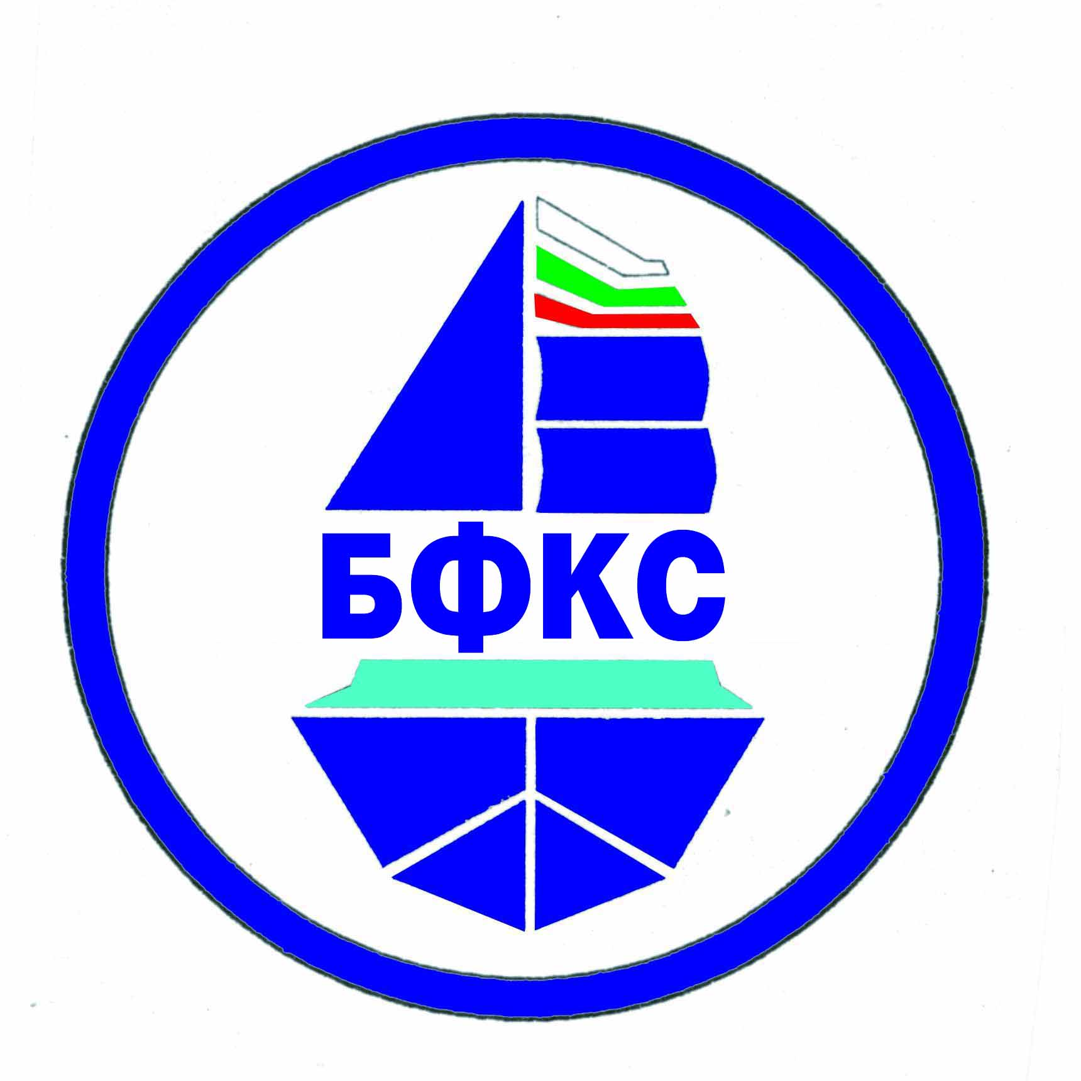
Bulgarian Federation of Modelsipsport

REGULATIONS
For Participation in the 22th European championship of Modelshipsport for Speed Modelships – Classes A/B
From 12 august to 17 august 2025 in the town of Pazardzhik, the Republic of Bulgaria
Organizer | World Organisation for Modelshipbuilding and Modelshipsport NAVIGA  Bulgarian Federation of Modelshipsport  Municipality Pazardzhik
Executor | Bulgarian Federation of Modelshipsport  Model Yacht Club - Pazardzhik
Place | “Liberty Island” Park, the town of Pazardzhik, the Republic of Bulgaria
Time of Holding | From 12.08.2025 to 17.08.2025
Chief Justice | Evgeni Genov - BG
Representative of NAVIGA | Hrachya Shahazizyan – Leader of Section A/B – NAVIGА
Technical Director | Petko Petkov - BG  E-mail: myachtklub@bfkks.com
Chief Secretary | Zdravka Dimitrova - BG
Rules | NAVIGA – 01.01.2018
Classes | A1, A2, A3, B1, A1E, B1E
Allowed number of models from a national federation | Each country has the right of 10 participants in a class, plus the european champion from 2023. After accepting the applications, there must be at least 10 participants from 5 countries in each class of the senior and 5 participants from 3 countries of the junior. The juniors must not be older than 18 in 2025.
Age Groups | Man and youths
Other Requirements | - Judges are not allowed to participate as competitors.  - By 15.06.2025 the Executor will inform all teams about the number of the registered competitors in each class and about in which classes there will be starts held valid for classification for the European Competition. In classes where there are fewer competitors than 10 for the senior and fewer than 5 for the junior the title European Champion will not be awarded.  - At registration, the leader of the teams have to provide the organizer with 3 / three/ national flags in the size of 1/1.50 m a  - The competitors in E classes have to provide the range of their radio appliances and the numbers of the quartzes, without any 2.4 MHz /DSM/.
Deadline for receiving applications | 10.06.2025  We would like you to send as your application both electronically and on paper.
Confirmation of received application by the executor | The executor will confirm each application within 5 days at an e-mail mentioned by the applicant. We would like you to provide us with fax number or postal address if you do not have an e-mail.
Latest possible date for arrival | 13.08.2025

Registration | From 08:30 to 12:00 on 13.08.2025 at Model Yacht Club – Pazardzhik, “Liberty Island” Park
Technical Conference | On 13.08.2025 at 12:00 at Model Yacht Club – Pazardzhik
Medals, Honorary Diplomas and Other Prizes | - Medals and honorary diplomas; Diplomas for all  - “Dimitar Ganchev” Bowl for best competitor
Initial Fees | For Seniors – 40 Euro for first class,for each other -30euro, Juniors – no, +8 Euro – insurance for person
Price of Fuel | For A1, B1 – 3 Euro, A2 – 4 Euro, A3 – 6 Euro ,B1E,A1E-3Euro  Please, send the fees for participation, booking the hotel and for the reception in advance to the enclosed bank account.
Fee for Protests | 20 Euro
Addresses for Sending the Applications | By 10.06.2025 – at E-mail: panajotov@bfkks.com  Postal address: Recipient: Kolya Panayotov, 211, Krasno Selo Housing Estate, Entrance 2, flat 32, the city of Sofia 1618, Bulgaria  Tel.: +3598564147, Mobile phone: +359888227837
Banquet | On 15.08.2024 at 20:00
Bank Account in Euro for sending the initial fees, the fees for fuel and the reception. | IBAN - BG13STSA93000011368935  BIC - STSABGSF  DSK Bank AD, F.C. Sofia - 3, Bul. Dondukov № 5,  Sofia, 1618, Krasno Selo district, residential complex Krasno Selo, bl. 211, ent. B, ap. 32. : Kolya Panayotov
Accommodation and Food | *** Trakiya Hotel, Tel.: +35934466006, E-mail: trakijaburo@abv.bg. www.Hotel-Trakia.domino.bg  **** Hebar Hotel, Tel.: +35934990000, E-mail: reservation@grandhotelhebar.net, www.grandhotelhebar.net
Deadline for updating your booking with regard to the accommodation:

Bulgarian Federation of Modelshipsport Model Yacht Club – Pazardzhik
Chairman: /Е.Genov/ Chairman: /P.Petkov /

